Reducing the Height of Plastic Ties

In laying flex track, Micro Engineering in my case, I remove a couple ties as necessary at each joint to clear the joiners and to allow easy trimming of the rails. Once the track is down, you need to fill in the missing ties.

One problem is that they need to be a little shorter in height than they are. I tried filing and sanding but holding them is a problem.

In selecting ties to resize, I found that those from the turnouts use a plastic that is harder and gives off a lot of fumes. The ties from the flex track are softer and work well. For identification, the turnout ties are lighter in color and a matte finish where the flex track ties are shiney.

Here is the method that worked for me.

First, I took my desktop vise and added a piece of foam weather stripping to one face near the top.

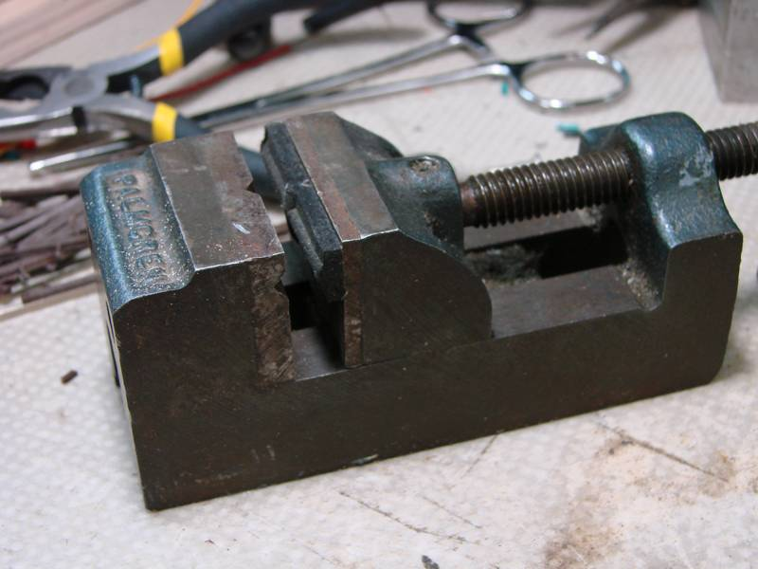

Next, I place a tie to be trimmed on the foam and press down until the amount I want to remove is sticking up above the vise jaws. When it is in the correct position, tighten the vise.

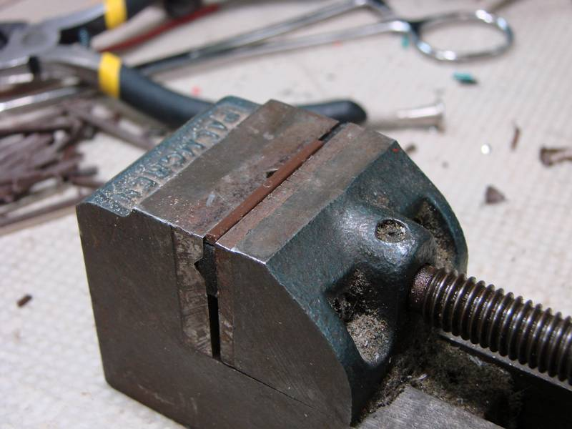

Using a wood burning iron I run it across the tie using the vise jaws as a guide. Set as shown at the edge, the roll of removed plastic falls to the workbench out of the way and the metal jaws of the vise are a great heat sink to cool the tie.

Be sure to set up a small fan to blow the fumes of the melting plastic away from you or your eyes will water, ask me how I know.

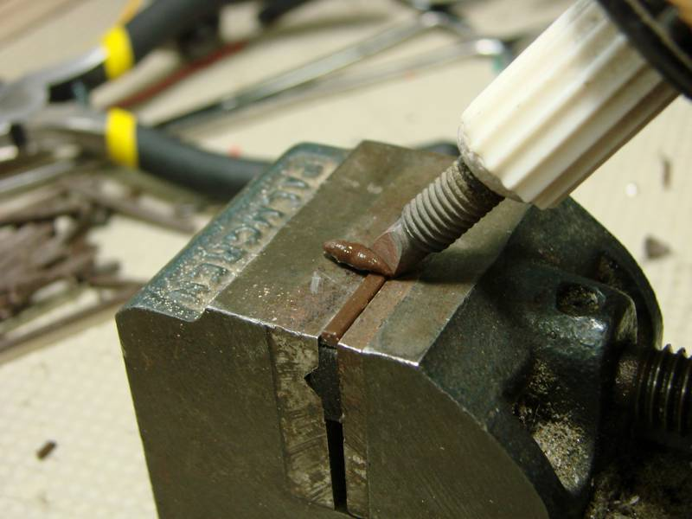

Here is the finished tie before it is removed. It will cool in the time it takes you to replace the iron in its stand.

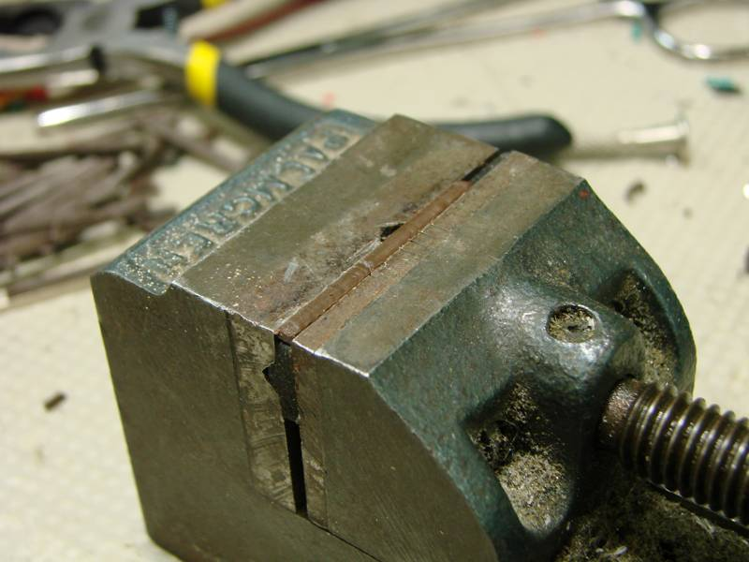

Jim Exler, Nampa, ID 9/16/2020